BOOKS of ML

Start with this:<https://jakevdp.github.io/PythonDataScienceHandbook/index.html>

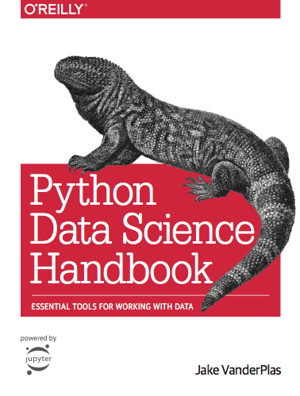

Progress with this: <https://github.com/ageron/handson-ml>

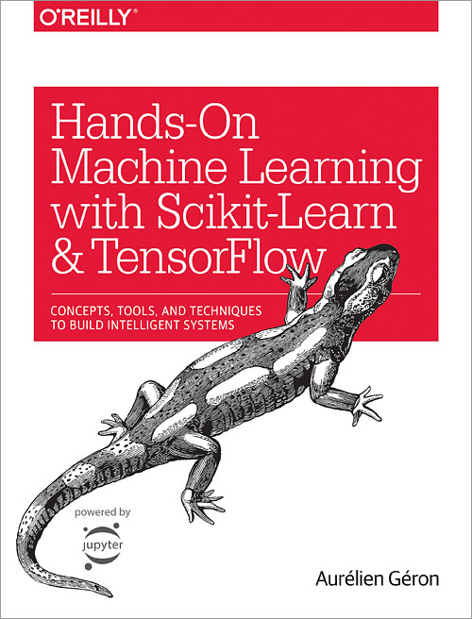

Blogs

<https://medium.com/topic/data-science>

<https://towardsdatascience.com/>

Online Courses

**Free**: Coursera - Andrew NG course (title: Machine Learning) for mathematical details

**Cheap**: Udemy: Authors Jose Portilla, Kiril Emereko

LINKEDIN PEOPLE

They often publish links to ML books - FREE PDF

